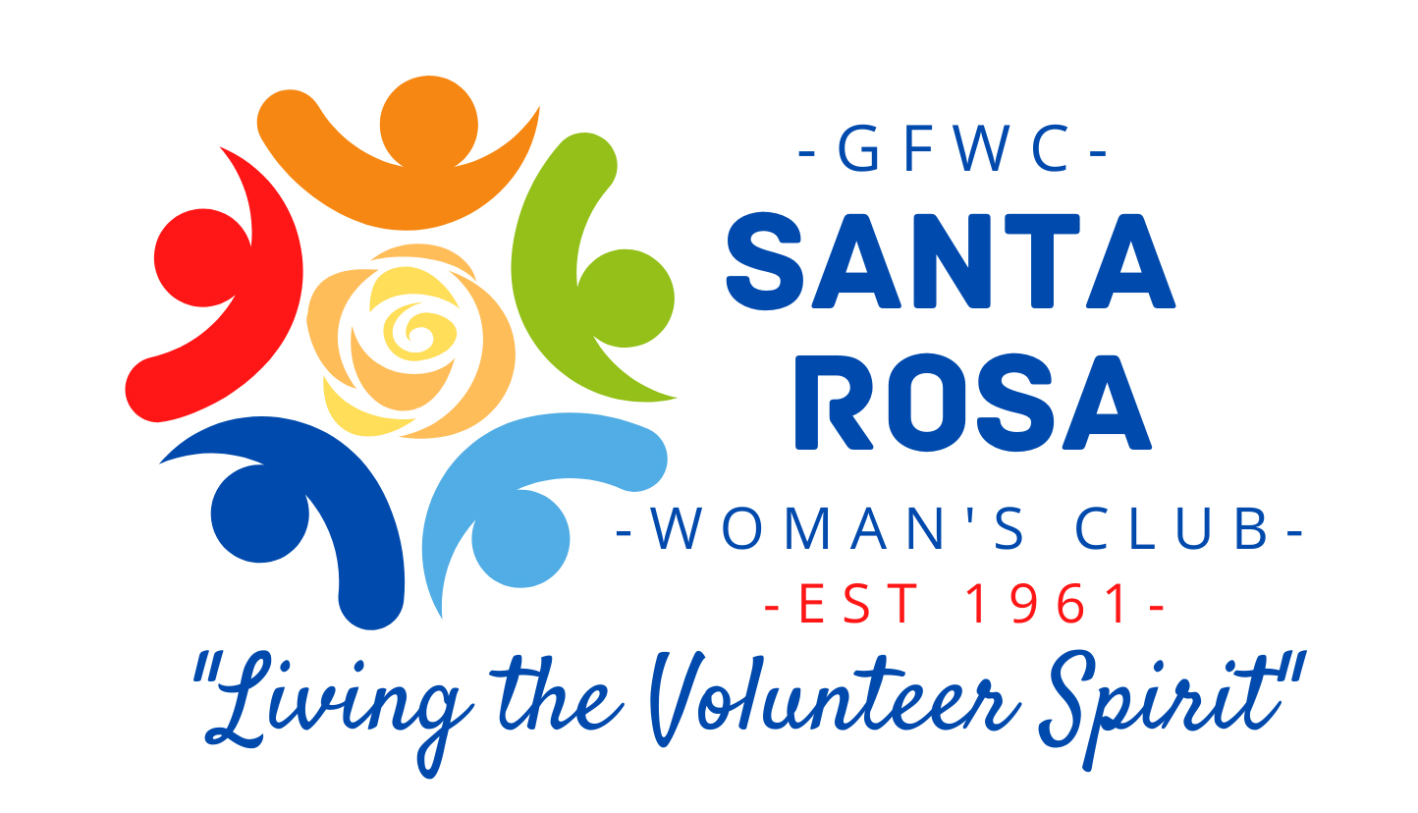

P.O. BOX 423
GULF BREEZE, FL 32562-0423
srwcwomansclub@gmail.com

“Celebrating more than 61 years of service to Gulf Breeze”

2023 SCHOLARSHIP ANNOUNCEMENT

Are you considering a career in a Technical/Vocational Field?

Apply now for a $500 Scholarship from GFWC Santa Rosa Woman’s Club.

To Apply
- Applicants should complete and submit the attached application.
- Email or mail with a postmark on or before FEBRUARY 15, 2023.
  - Email – srwcwomansclub@gmail.com
  - Mail - Scholarship Chairman, GFWC Santa Rosa Woman’s Club, P.O. Box 423, Gulf Breeze, FL 32562-0423.

About GFWC Santa Rosa Woman’s Club (SRWC)

GFWC Santa Rosa Woman’s Club announces its annual scholarship process. This
year, there will be several Technical/Vocational School scholarships offered to women. The scholarships are open to individuals attending a Technical/Vocational school without regard to marital status or full-time or part-time enrollment. This scholarship is also available to woman seeking further education so that they may return to the workforce. Scholarship award money is paid directly to the school upon proof of the recipient’s enrollment. It is the recipient’s responsibility to provide proof of enrollment. Please feel free to contact Val at 334-477-3516 if you have any questions.

APPLICATION GFWC SANTA ROSA SCHOLARSHIP 2023

(Email or Postmark deadline by February 15, 2023. GFWC Santa Rosa Woman’s Club, P.O. Box 423, Gulf Breeze, FL 32562-0423 srwcwomansclub@gmail.com . Additional information may be attached.)

PERSONAL DATA
Name:
Address:
Phone:
Email:

EDUCATION STATUS
What degree or program of study are you pursuing?

List the names of the institutions to which you have applied; Indicate ones to which accepted.

FINANCIAL STATUS
Have you applied for financial aid (student loans, grants, work-study)?
No
Yes

Name______________________

Are you currently a recipient of financial assistance from other sources such as, trusts, grants, scholarships, agencies or Bright Futures?

No
Yes

If Yes, List:

Explain any special personal, family or financial situation you believe merits consideration in the award of this scholarship:

FUTURE GOALS

What are your education and career goals and how will this award help you achieve these goals? (300 words or less OR maximum of a 3-minute video). Email, video or place video on a thumb drive and mail it with your application.

Include in written statement or video - The motto of The General Federation of Women’s Clubs is “Living the Volunteer Spirit.” Explain how you, as a woman, have made or can make a difference in your community by living the volunteer spirit.

The information provided on this application is complete and accurate to the best of my knowledge. I understand that the information provided herein will be used only for scholarship selection purposes.

I understand the scholarship funds will be awarded to the vocational /technical college or university, and failure to register and attend will result in the forfeit of the scholarship. The funds must be used within one year of the award notification.

I understand that I am responsible for any additional expenses in this program that may not be covered by financial aid, scholarships, or other funding sources.

I understand that I am expected to have good attendance, make adequate progress in my classwork, lab/shop experiences and internship experiences (as applicable) to remain in good standing with the SRWC.

By typing in my signature below, I affirm the application was completed by this applicant.

Name:
Signature: |  |  |  | Date:
 |  | signature accepted as a valid hand signature

