GFWC Florida
Booster Club Application Form

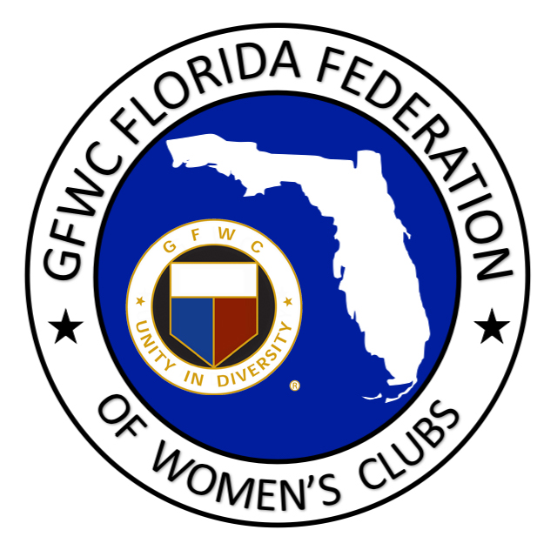

GFWC Florida has a Booster Club! This offers you an opportunity to invite your husband, significant other, friends and family to join and support our Federation family.

Membership cost is $10.00. Membership is valid from May 2020-May 2022 and may be renewed. New members receive a booster pin.

BOOSTER’S NAME:

CLUB MEMBER’S NAME:

CLUB MEMBER’S STREET ADDRESS:

CITY/STATE/ZIP:

PHONE:

EMAIL:

CLUB NAME:

DISTRICT #:

IS THIS A RENEWAL?:

Make $10.00 check payable to GFWC Florida and mail to:
GFWC Florida
4444 Florida National Drive
Lakeland, FL 33813

Thank you!

